Work in pairs, with one person using the mouse and the other person taking notes on this worksheet. Switch roles as you go from one question or sketch page to the next.

Warm-Up

1. What did you notice about this challenge?

2. What did you wonder?

Reflect Dance 1

|  |  |
| --- | --- |
| 3. Draw a diagram showing how each of you moved for the first dance. | 4. Did both of you move in the same direction? |

5. Describe how you and your partner moved during this reflect dance. When did you move in the same direction, and when did you move in opposite directions?

Interlude

5. How does this video relate to the reflect function you just danced?

Construct

6. On page 1, when you drag *x* what do you notice about how *rj*(*x*) moves? Draw pictures of the traces you made on pages 1 and 3.

7. On page 2, when you drag *x* what do you notice about how *rj*(*x*) moves? Draw a small picture of the traces you made.

 1. In the toolbox, tap 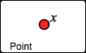. Then tap in the sketch, and *x* is placed!

2. Drag variable *x* around the screen.

3. Tap 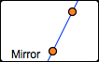. Tap or drag both glowing points.

4. Tap 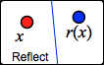. Attach the glowing *x* to the original *x*. The dependent variable is the *reflection* across line *j* of *x*. It’s called *rj*(*x*) for short.

**Q1** Make mirror *j* vertical, and then drag variable *x* up. Which way does *rj*(*x*) go? Draw a sketch to show what happened.

Drag independent variable *x* left. Which way does the dependent variable *rj*(*x*) go? Draw a sketch to show what happened.

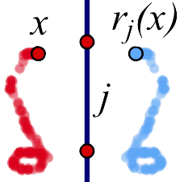 **Q2** Trace an interesting shape and describe it. How are the blue *rj*(*x*) traces similar to the red *x* traces, and how are they different? Include a drawing showing your shapes.

**Q3** Erase the tracing and do a new one. What happens when you drag *x* across the mirror? Describe the traced shapes, and include a drawing on your paper.

Match the Traces

 5. On page 2, contruct a segment. 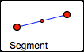



6. Construct *x* attached to the segment, **but not on the end points or midpoint.** Drag *x* to make sure it’s attached.

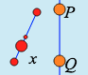

7. Construct a vertical mirror.

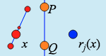 8. Tap . Attach the glowing *x* to the original *x*.

9. Tap 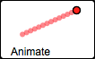 and attach the glowing *x* to the original *x*.

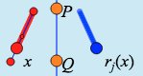

10. Notice the  button. Tap it. Then turn tracing on. The red traces show the *domain*. The blue traces show the *range*.

**Q4** Move the mirror and the segment, and use tracing to match the pictures below. In each box, draw a line to show where you put the mirror. Try to match all 5!

|  |  |  |  |  |
| --- | --- | --- | --- | --- |
|  |  |  |  |  |

**Q5** Describe the method(s) you used to place the mirrors. Did you develop new tricks as you did the five challenges?

Restrict the Independent Variable to a Polygon

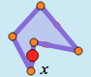 11. On page 3, tap 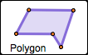 to make a polygon. Tap to place each glowing point.

12. Construct independent variable *x* on the polygon. Drag *x* to make sure it’s attached. (The polygon is now the domain.)

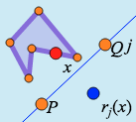 13. Construct a mirror. Then tap  and attach the glowing *x* to the original *x.*

14*.* Turn on tracing and drag or animate *x.* Adjust the polygon to make an interesting shape.

**Q6** Adjust your mirror so you can get *x* and *rj*(*x*) in the same place at the same time. A place like this is called a *fixed point* of the function. Adjust your polygon and mirror so there are two fixed points. Erase your traces and then animate. Draw a sketch below to show what you did.

**Q7** Adjust the domain (the polygon) so that on one side of the polygon the variables move in the same direction, and on another side they move in opposite directions. Draw a sketch to show how you did it.

Reflection Challenges

**Q8** On page 4, figure out where the mirror is that is reflecting the domain and range. How can you check your guess to be sure? Draw your solution below.

**Q9** On pages 5 and 6, there are two more find-the-hidden-mirror challenges. Solve them, and describe your methods. Draw a sketch for each solution. Which challenge was harder? Why?

**Q10** On page 7, find the mirror that reflects independent variable *x* to dependent variable *f*(*x*). Draw your solution below.

**1.** Describe one important thing you learned today about the reflection function family.

**2.** Describe one thing about the reflection function family that seems confusing to you.